PYTHON ACTIVITY BASED LEARNING
PROBLEM 3
Problem Statement:
Hospital Billing and Patient Classification: Process consultation, diagnostic, and treatment charges, apply conditional concessions, validate billing constraints, and classify patients according to a supplied payment policy
1. Objective
To develop a Python program that calculates hospital bills by adding consultation, diagnostic, and treatment charges. The system applies conditional concessions, validates billing constraints, calculates the final payable amount, and classifies patients according to a payment policy.
2. Program (Python)
# Hospital Billing and Patient Classificationname = input("Enter patient name: ")patient_type = input("Enter patient type (General/Senior): ")consultation = float(input("Enter consultation charges: "))diagnostic = float(input("Enter diagnostic charges: "))treatment = float(input("Enter treatment charges: "))# Validate billing constraintsif consultation < 0 or diagnostic < 0 or treatment < 0: print("Invalid billing: Charges cannot be negative.")else: total = consultation + diagnostic + treatment # Apply conditional concession if patient_type.lower() == "senior": concession = total * 0.20 elif total >= 10000: concession = total * 0.10 else: concession = 0 final_bill = total - concession # Classify according to payment policy if final_bill <= 5000: category = "Low Payment" elif final_bill <= 15000: category = "Medium Payment" else: category = "High Payment" print("\n--- Hospital Bill ---") print("Patient Name:", name) print("Total Charges: Rs.", round(total, 2)) print("Concession: Rs.", round(concession, 2)) print("Final Bill: Rs.", round(final_bill, 2)) print("Patient Classification:", category)
3. Algorithm
- Start.
- Input the patient's name and patient type.
- Input consultation, diagnostic, and treatment charges.
- Check whether any charge is negative.
- If any charge is negative, display an invalid billing message.
- Otherwise, calculate total charges by adding all three charges.
- Apply a concession:
  - Senior patient: 20% concession.
  - Other patient with a bill of ₹10,000 or more: 10% concession.
  - Otherwise: no concession.
- Calculate the final bill by subtracting the concession from total charges.
- Classify the patient according to the final bill:
  - ₹5,000 or less: Low Payment.
  - ₹5,001–₹15,000: Medium Payment.
  - Above ₹15,000: High Payment.
- Display the bill details and patient classification.
- Stop.
Flowchart
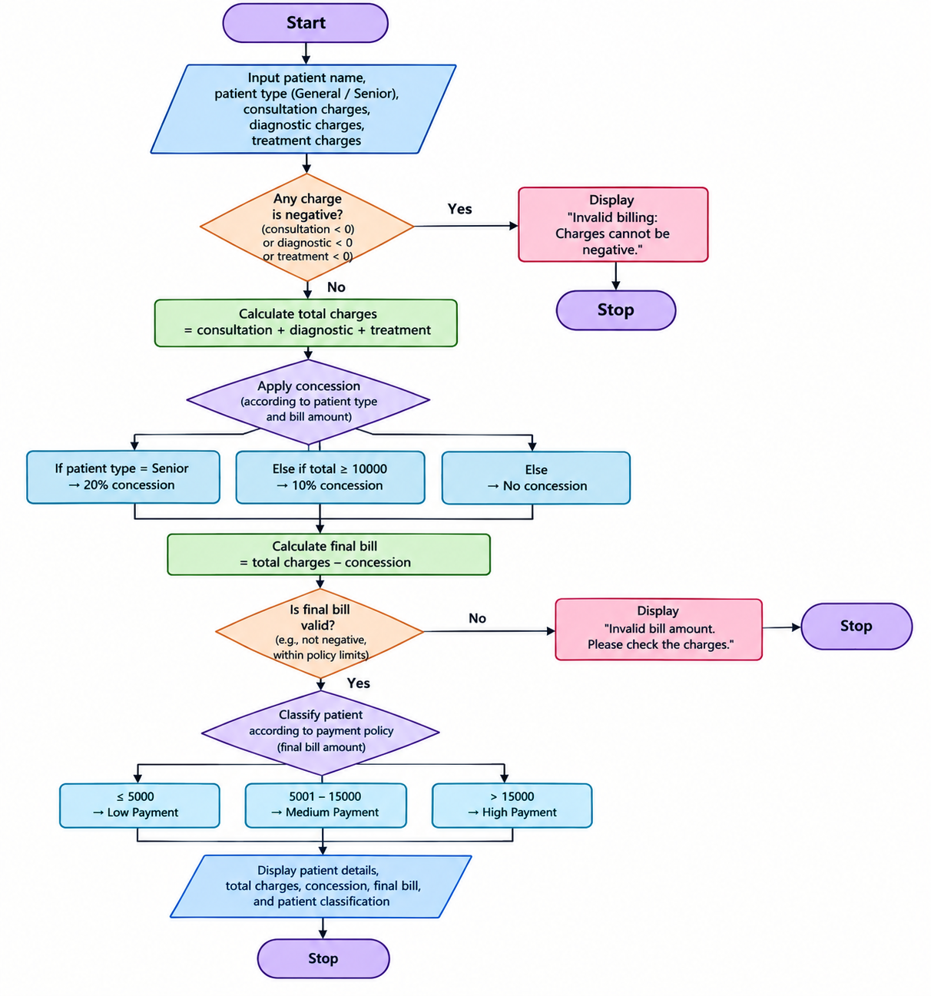
4. Pseudocode
BEGIN
INPUT patient_name, patient_type
INPUT consultation, diagnostic, treatment

IF any charge < 0 THEN
DISPLAY "Invalid Billing"
ELSE
total = consultation + diagnostic + treatment

IF patient_type = "Senior" THEN
concession = total * 20 / 100
ELSE IF total >= 10000 THEN
concession = total * 10 / 100
ELSE
concession = 0
END IF

final_bill = total - concession

IF final_bill <= 5000 THEN
category = "Low Payment"
ELSE IF final_bill <= 15000 THEN
category = "Medium Payment"
ELSE
category = "High Payment"
END IF

DISPLAY total, concession, final_bill
DISPLAY category
END IF
END
5. Sample Output
Enter patient name: Ravi
Enter patient type (General/Senior): General
Enter consultation charges: 1000
Enter diagnostic charges: 4000
Enter treatment charges: 6000

--- Hospital Bill ---
Patient Name: Ravi
Total Charges: Rs. 11000.0
Concession: Rs. 1100.0
Final Bill: Rs. 9900.0
Patient Classification: Medium Payment
Result
The program successfully calculates the hospital bill, applies eligible concessions, validates charges, and classifies the patient based on the final payable amount.

